**JSJD & KAMPRS**

**The Conjunction Executive Meeting 2024 (June)**

**Agenda**

**1. Welcome remarks from Professor Keiji Moriyama (President of JSJD)**

**2. Congratulatory message from Professor Jeong-Keun Lee**

**(President of KAMPRS)**

**3. Introduction of the board members of both societies**

**(List of the board members)**

**4. Welcome remarks from JSJD Congress 2024**

**(Congress Chairman: Prof.Yoshiki Hamada)**

**5. Announcement of KAMPRS Congress 2024**

**(Congress Chairman: Prof. Young-Soo Jung)**

**6. Introduction of JSJD Congress 2025**

**(Congress Chairman: Prof. Izumi Yoshioka)**

**7. Others**

**1. Welcome remarks from Professor Keiji Moriyama (President of JSJD)**

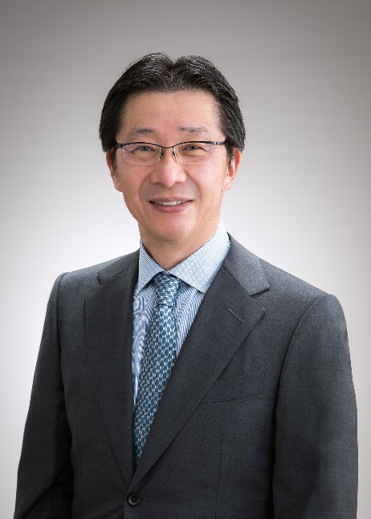

It is a great honor for us to welcome the delegates of the KAMPRS to the 34th Annual Meeting of the JSJD, which is held on June 27-28, 2024 in Tokyo, Japan under the leadership of Congress Chairman, Dr. Yoshiki Hamada, Professor and Chair of Department of Oral & Maxillofacial Surgery, School of Dental Medicine, Tsurumi University. All the members of the JSJD are hoping to share the most advanced scientific and clinical knowledge and expertise related to jaw deformities with you all through this special occasion.

I also would like to express my heartfelt appreciation for your participation in the JSJD-KAMPRS Conjunction Meeting. This must provide an ideal opportunity to update information on future annual meetings, academic collaborations, and social interactions between the two associations.

Please accept my heartfelt gratitude to you all for your continuous support and I look forward to seeing you in person at the upcoming meeting in Tokyo soon.

Yours Sincerely,

Keiji Moriyama, D.D.S., Ph.D.

President, The Japanese Society for Jaw Deformities

Professor and Chair, Department of Maxillofacial Orthognathics,

Tokyo Medical and Dental University

**2. Congratulatory message from Professor Jeong-Keun Lee**

**(President of KAMPRS)**

Facial Photo of Prof. Lee

Dear President, board directors, and all members of JSJD, congratulations on the opening of the annual congress of JSJD, June 2023.

I am very happy that the academic exchange between the two societies has resumed after 3 years due to COVID-19.

On behalf of KAMPRS, I would like to express my sincere gratitude to the JSJD, on behalf of KAMPRS, to the members of the society who have taken care to present and participate as speakers at the JSJD annual meeting. All KAMPRS members applaud the successful hosting of the JSJD Annual Meeting. I'm really looking forward to attending the JSJD Annual Meeting this time and interacting with many friends.

We would like to express our appreciation to Professor Keiji Moriyama, the President of the JSJD, and Professor Naoto Suda, the 2023 Congress Chairman.

Thank you for the efforts preparing the KAMPRS-JSJD Joint Board meeting as well.

I believe it will be a milestone in strengthening our friendship and expanding academics.

I hope to see you all in Gangneung 2023 KAMPRS Annual Meeting!

**Jeong Keun Lee**

Department of Oral and Maxillofacial Surgery,

Ajou University School of Medicine,

Suwon, South Korea

**3. Introduction of the board members of both societies (List of the board members)**

**<JSJD current Directors>**

|  |  |
| --- | --- |
| Keiji Moriyama  President of JSJD,  Department of Maxillofacial Orthognathics, Graduate School of Medical and Dental Sciences, Tokyo Medical and Dental University |  |
| Naoto Suda  Vice President of JSJD,  Division of Orthodontics, Department of Human Development and Fostering, Meikai University School of Dentistry |  |
| Yoshihiko Yokoe  Vice President of JSJD,  Kyoto Jaw Deformity Center, Rakuwakai Otowa Hospital |  |
| Tomonao Aikawa  Department of Oral and Maxillofacial Surgery, Graduate School of Biomedical and Health Sciences, Hiroshima University |  |
| Koichiro Ueki  Department of Oral and Maxillofacial Surgery, Division of Medicine, Interdisciplinary Graduate School, University of Yamanashi |  |
| Takashi Ono  Department of Orthodontic Science, Graduate School of Medical and Dental Sciences, Tokyo Medical and Dental University |  |
| Tatsuo Kawamoto  Division of Orofacial Functions and Orthodontics, Faculty of Dentistry, Kyushu Dental University |  |
| Yasushi Nishii  Department of Orthodontics, Tokyo Dental College |  |
| Yoshiki Hamada  2024 Congress chairman,  Department of Oral and Maxillofacial Surgery, School of Dental Medicine, Tsurumi University |  |
| Kensuke Yamauchi  Division of Oral and Maxillofacial Reconstructive Surgery, Graduate School of Dentistry, Tohoku University |  |
| Takashi Yamashiro  Department of Orthodontics and Dentofacial Orthopedics, Graduate School of Dentistry, Osaka University |  |
| Izumi Yoshioka  2025 Congress chairman,  Department of Oral Medicine, Kyushu Dental University |  |
| <Auditors>  Seiji Iida  Department of Oral and Maxillofacial Reconstructive Surgery, Graduate School of Medicine, Dentistry and Pharmaceutical Sciences, Okayama University |  |
| <Auditors>  Yoshiaki Sato  Department of Orthodontics, Division of Dental Medicine, Faculty of Dental Medicine, Hokkaido University |  |
| <Society secretary>  Norihisa Higashihori Department of Maxillofacial Orthognathics, Graduate School of Medical and Dental Sciences, Tokyo Medical and Dental University |  |

**<KAMPRS Current Directors>**

|  |  |
| --- | --- |
| **President: Lee, Jeong-Keun  Department of Oral and Maxillofacial Surgery,**  **Institute of Oral Health Science, Ajou University School of Medicine** | EMB000041743528 |
| **Vice President: : Jung, Young-Soo**  **Congress Chairman of KAMPRS 2024**  **Department of Oral and Maxillofacial Surgery,**  **College of Dentistry, Yonsei University** | EMB000041743529 |
| **Vice President : Ahn, Kang Min  Department of Oral and Maxillofacial Surgery,**  **College of Medicine, University of Ulsan, Asan Medical Center** | EMB00004174352a |
| **Secretary: : Kim, Yong-Deok  Department of Oral and maxillofacial surgery,**  **School of dentistry, Pusan National University, Yangsan** | EMB00004174352b |
| **Academic Affairs: Park, Joo-Young  Department of Oral and Maxillofacial Surgery,**  **Seoul National University School of Dentistry** | EMB00004174352c |
| **Education Affairs: Jun, Sang Ho  Department of Oral and Maxillofacial Surgery,**  **Korea University Anam Hospital** | EMB00004174352d |
| **Editor-in-Chief in MPRS journal: Dae Seok Hwang  Dental Research Institute, Department of Oral and Maxillofacial Surgery, School of Dentistry, Pusan National University, Pusan National University Dental Hospital, Dental Research Institute** | EMB00004174352e |
| **Legal and Regulatory Affairs Jin-Woo Kim**  **Department of Oral and Maxillofacial Surgery, Mok-dong Hospital, School of Medicine, Ewha Womans University, Seoul, Korea** | EMB00004174352f |
| **International Relations: Young-Min Shin**  **Department of Dentistry and Oral Surgery, Dong-San Medical Center, Keimyung University** | EMB000041743530 |
| **External and Public Relations: Jun-Young Kim**  **Department of Oral & Maxillofacial Surgery, Yonsei University College of Dentistry** | EMB000041743531 |
| **Treasurer: Hoon Joo Yang**  **Orthognathic Surgery Center, Seoul National University Dental**  **Hospital,** | EMB000041743532 |
| **Insurance Director: Jeong-Kui Ku**  **Department of Oral and Maxillofacial Surgery,**  **Section of Dentistry, Seoul National University Bundang Hospital** | EMB000041743533 |

**4. Welcome remarks from JSJD Congress 2024 (Congress Chairman: Prof. Yoshiki Hamada)**

It is my great pleasure to welcome KAMPRS members to the 34th Annual Meeting of the Japanese Society for Jaw Deformities (JSJD) at Tokyo Big Sight TFT Hall from June 26 to 28, 2024. Also, I really appreciate that more than 20 abstracts and many KAMPRS members were registered in our Congress.

The main theme of our Congress is “Wisdom Concentration for the Treatment of Jaw Deformities”. As an international special lecture, Prof. Dr. Dr. Peter Kessler will talk about “Symmetry of the face”. He is one of the greatest wisdoms for jaw deformities and Prof. & Chairman of the Department of Cranio-Maxillofacial Surgery, Maastricht University. Furthermore, Prof. Takayuki Nagashima, Prof. & Chair of the Human Animal Relations Department, Yamazaki University of Animal Health Technology, will give us an educational lecture concerning on the insect technology contributing to the sustainability. In addition, we plan to have 5 symposiums including lectures by Prof. Jae-Min Song and Prof. Ui-Lyong Lee who are representative speakers of KAMPRS.

In any case, I strongly expect fruitful discussion on each topic together with KAMPRS members and your joyful staying in Tokyo.

Sincerely Yours,

Yoshiki Hamada

Congress Chairman:

The 34th Annual Meeting of JSJD

Professor & Chairman:

Department of Oral & Maxillofacial Surgery,

School of Dental Medicine, Tsurumi Univarsity

**5. Announcement of KAMPRS Congress 2024**

**(Congress Chairman: Prof. Young-Soo Jung)**

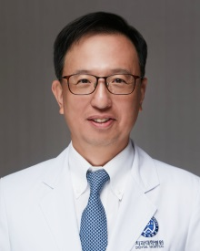

Presentation would be provided with PPT.

**6. Introduction of JSJD Congress 2025 (Congress Chairman: Prof. Izumi Yoshioka)**

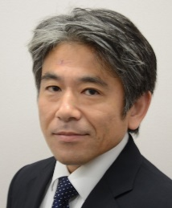

Dear KAMPRS President, Prof. Sun-Jong Kim and board directors,

It is my honor to announce that the 35th Annual Meeting of the Japanese Society for Jaw Deformities (JSJD) will be held at Kitakyushu International Conference Center (KICC) from June 4 to 6, 2025.

The main theme of the Congress is “Multi-faceted approach to Jaw Deformities”.　As an international special lecturer, we have invited Prof. Berthold Hell from Germany. He is one of great wisdoms for cranio-facial surgery.

Furthermore, we are planning a wide variety of content for the Congress, to include, educational lectures, and a range of symposiums, video sessions, and lectures for young doctors.

Kitakyushu City is situated in the northern area of Fukuoka prefecture, at the northernmost tip of the Kyushu island. Kitakyushu is full of tourist attractions, such as the UNESCO World Heritage-registered industrial modernization sites, the Mojiko Retro area with a nostalgic atmosphere, and spots where you can enjoy Japanese subculture like manga and anime.

I look forward to a large number of abstract submissions, and hope that as many people as possible will attend the Congress and contribute to making it a highly successful event.

Sincerely Yours,

Izumi Yoshioka

Congress Chairman:

The 35th Annual Meeting of JSJD

Professor & Chairman:

Department of Oral Medicine,

Kyushu Dental University

**7. Others**